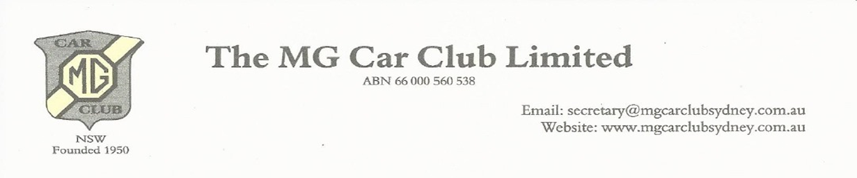
Club Declaration

Application for/or Renewal of Conditional Registration (Including 60 day Log Book Trial)
Historic Vehicle Scheme (HVS) or Classic Vehicle Scheme (CVS)
In applying for Conditional Registration with ‘The MG Car Club Limited’ as my Primary club, I declare that I have read and understood the rules relating to Conditional Registration supplied by the M.G. Car Club and the Roads and Maritime Services. By signing this form I accept full responsibility for the operation and upkeep of the vehicle and to act in accordance with the rules for this special registration scheme.

The vehicle for which I seek MGCC endorsement complies with the RMS Policy in one of the two following schemes (read Vehicle Standards Instruction (VSI-06) if you are unsure):
Tick One
Scheme A: Unmodified whereby the vehicle has no modifications which, listed under VSI-06, require a motor engineer’s certification and, therefore, qualifies for the Historic Vehicle Scheme (HVS)
Scheme B: Modified whereby the vehicle carries modifications, as listed under VSI-06, which require a motor engineer’s certification and therefore qualifies for the Classic Vehicle Scheme (CVS)
I seek MGCC endorsement and certify that the vehicle qualifies for Conditional Registration for the selected scheme and I agree to maintain it in this condition.

Name ……………………………………………………………………Membership Number…………..Plate number………………………

Date …………………………………………… Signature…………………………………………………………..

