2026 Northern NSW Pre War and pre 1956 MG Rally
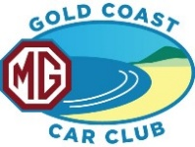
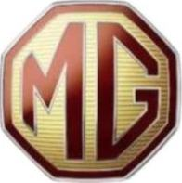
From the beach to the mountains
Registration Form
This Rally is open to custodians of Pre War and Pre 1956 MGs to participate in their MGs.
The Rally based out of Kingscliff, NSW, will run from the Welcome Meet & Greet on Monday 11 May and finish with a Celebration Dinner on Thursday 14 May 2026.
The Rally will include runs of between 100 and 150 km on Tuesday and Thursday and a longer run of around 200km on Wednesday when we travel up into the hinterland mountains.
A fee of $125 per person attending is required to be paid prior to Registration acceptance. (Payment details are included in the email this form was attached to)

To complete the form on your PC, tablet, etc, you need to ‘Enable Editing’ before entering information. To enter information click the start of each field and enter the information. Save it, using ‘Pre56 Rally (your name)’. (You cannot edit the form once saved.) Email the saved document back to me at lesley_stuart@bigpond.com .

Participant / Driver
Other participants (List all other participants)

Residential Address
Suburb, State & Post code

Phone number(s) whilst at Rally
Email Address

Emergency Contact name & Ph
(not at Rally)

MG Club you are a member of

MG you are participating the Rally in
Model | Year built | Body colour | Rego #

If you have booked accommodation, where (for Celebration Dinner courtesy bus information)

Food Allergies or special dietary request(s)

☐ I / we, the participants named above, agree to abide by all directions of the Rally Organisers and the Gold Coast MG Car Club Inc rules, as set out on the Club’s website.
☐ I/we have paid $125 per participant registration fee.

